**CHAPTER III**

**TECHNICAL PROCESS PLANS**

**3.1. Functional Description**

**3.1.1. Current Functional Description**

**CASE 1:** Students go to the faculty department if needed a consultation. A receptionist is available at the lobby. She checks the faculty schedule and their availability for consultation. If the faculty is available, receptionist will call the faculty department to inform the faculty that a student is looking for them. They will meet at the lobby or in a conference room. There is a log book available at the counter where student can write the date, time, purpose, and the faculty name but it is not strictly implemented.

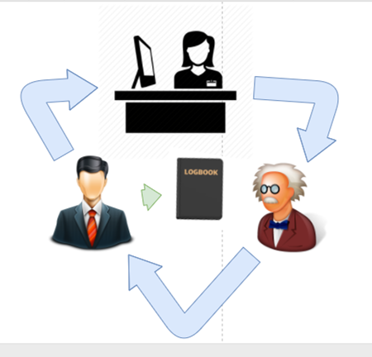

**Figure 3.1 Student consultation Diagram through faculty receptionist**

**CASE2:** The student and faculty meet on their convenient time. The meetings are not documented unless there's a need for a “Minutes of the Meeting” or a meeting invite was sent through outlook.

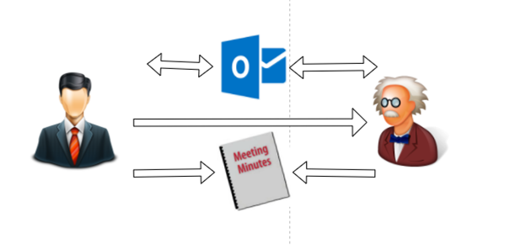

**Figure 3.2 Student Consultation Diagram through Scheduled Meeting**

**3.1.2 Proposed Functional Description**

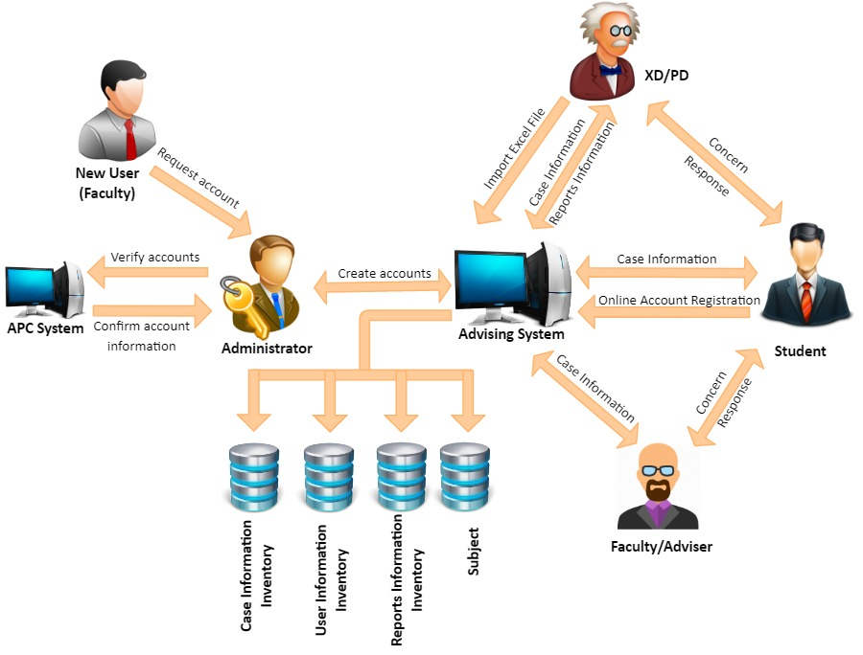

**Figure 3.3 Proposed Functional Description**

The new design will use automation. It will be a system that will that will create, save, update, and retrieve advising details effectively and efficiently. All interaction will be save in a database, so all the authorized users can access the records.

To make the system accessible, each user will have an online account. The student information will be imported in bulk by directors. Once done, they can proceed with online self-registration where they can verify setup their login and security information. Faculty online account will be setup by admin.

A consultation or advising regardless of concern will be called a case. A case will represent an interaction between a student and a faculty. It will be academic or curricular in nature and the user can further describe the category of concern by the available dropdowns. A case does contain indicators for reporting purposes. Users can exchange notes on a case and the notes are stamped with date and time, user ID. All pending cases will show up on the users’ homepage and those cases that has no activity 30 days after the last added notes will automatically change its status from "Open" to "Automated Close".

The following are the modules available in the system: 1. Registration Module; 2. Login Module; 3. Case Module; 4. Importing Module; and 5. Reporting Module;

The Login Module is the first page that the user can see when they visit the system. This module allows the user to enter the user ID and password. This information is required before accessing the other modules for security verification. The login module also has an account recovery feature. This feature allows the user to enter the answers to the security questions in case the password has forgotten. The security questions were the question selected during the registration.

Registration Module would be the module used to setup the login and security account information. This module would be accessible to student after they received an auto generated email that contains a link. This link directs to the registration module. The users have to fill up the forms to complete the registration process.

The Case Module allows the users to create, save, retrieve and update a case. An interaction is equivalent to a case. It has nature, category, and sub-category that would help users to properly describe the nature of the case. This category selection can be changed by executive director by importing new list. This feature is provided to executive director for system flexibility. A case does contain attributes. A case will have a case ID. It is a unique case indicator that is system generated. It is only shared by a faculty and a student. A case if left unattended or no activity will automatically close by the system. Its status will change from open to automated closed if no activity 30 days after the last added notes.

The Importing Module allows the users with directors’ level to manage database records in bulk.

Importing data:

The executive/ program director has the capability to import files on the system. This data will be used as records on the database. The following are the list of tables that they can import:

-List of Offered Subjects and the faculty that will facilitate (current term)

-List of Student currently enrolled (per subject)

-List of Student Information

-List of Cluster and its respective adviser

-List of Student (per cluster)

Registration Process:

For student - They have to do a self-registration. the student information should be imported prior to the registration. There will be an email that will be sent to the student after the import is done.

For faculty - They have to coordinate to the administrator to setup their account.

Create/ Managing a case:

The list of all open case will be available on the user home screen right after they login. This is for the user to effectively manage their cases. The data can be sorted depending on the users preferred field. To view the case detail, the user can simply click on the case number and it will be directed to the case detail page. This page contains the student information and the case detail such as the case title, notes, nature, etc. The student and the faculty can exchange notes within the case. It notes will be stamped with their user ID, date, and time. Once the notes is saved, it cannot be deleted nor modified. Cases that has no activity within 30 30 days after the last added noted will be automatically closed by the system by changing the case status from "Open" to "Automated Close".

**3.2. Data Model**

**3.2.1. Entity-Relationship Diagram (ERD)**

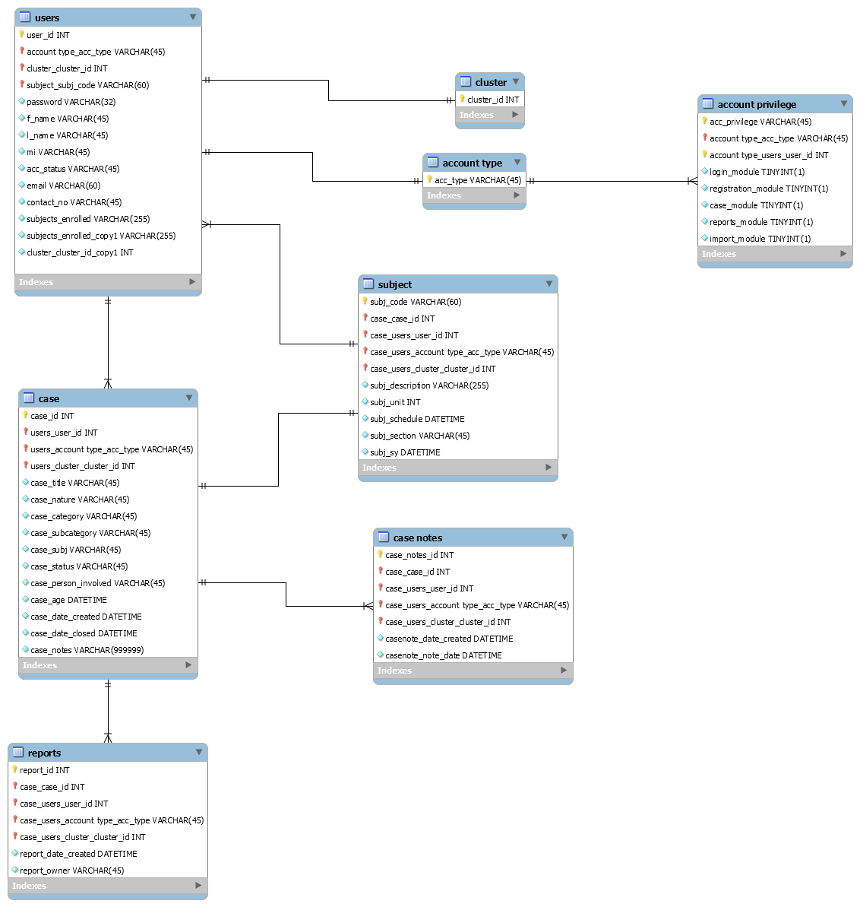

**Figure 3.4 Entity Relationship Diagram**

In figure 3.4, the Entity Relationship Diagram (ERD) in our system used the crowfoot notation. It is a bit simpler than the chen and a bit cleaner to look at. Our tables composed of primary keys that are interconnected to other tables as foreign keys. There are 14 tables in the diagram. The tables consists of the user, case, case notes, subject, cluster, account privilege, account type, and the six user entities which are the student, faculty, adviser, program director, executive director, and admin.

**3.2.2. Entity Attribute List**

**Table 3.1 Entity Attribute List**

|  |  |  |  |  |
| --- | --- | --- | --- | --- |
| **Table Name** | **Attribute Name** | **Data Type** | **Required** | **Key** |
| Users | user_id | INT | YES | PK |
| Users | password | VARCHAR | YES |  |
| Users | f_name | VARCHAR | YES |  |
| Users | l_name | VARCHAR | YES |  |
| Users | mi | VARCHAR | YES |  |
| Users | acc_status | VARCHAR | YES |  |
| Users | acc_type | VARCHAR | YES |  |
| Users | email | VARCHAR | YES |  |
| Users | contact_no | VARCHAR | YES |  |
| Users | subject_enrolled | VARCHAR | YES |  |
| Users | cluster_id | INT | YES | FK |
| Case | case_id | INT | YES | PK |
| Case | user_id | INT | YES | FK |
| Case | case_title | VARCHAR | YES |  |
| Case | case_nature | VARCHAR | YES |  |
| Case | case_category | VARCHAR | YES |  |
| Case | case_subcategory | VARCHAR | YES |  |
| Case | case_subj | VARCHAR | YES |  |
| Case | case_status | VARCHAR | YES |  |
| Case | case_person_involved | VARCHAR | YES |  |
| Case | case_age | DATETIME | YES |  |
| Case | case_date_created | DATETIME | YES |  |
| Case | case_date_closed | DATETIME | YES |  |
| Case | case_notes_id | INT | NO | FK |
| Case Notes | case_notes_id | INT | YES | PK |
| Case Notes | user_id | INT | YES | FK |
| Case Notes | casenote_date_created | DATETIME | YES |  |
| Case Notes | casenote_note_date | DATETIME | YES |  |
| Subject | subj_code | VARCHAR | YES | PK |
| Subject | user_id | INT | YES | FK |
| Subject | subj_description | VARCHAR | YES |  |
| Subject | subj_unit | INT | YES |  |
| Subject | subj_schedule | DATETIME | YES |  |
| Subject | subj_section | VARCHAR | YES |  |
| Subject | subj_sy | DATETIME | YES |  |
| Cluster | cluster_id | INT | YES | PK |
| Cluster | user_id | INT | YES | FK |
| Reports | report_id | INT | YES | PK |
| Reports | report_date_created | DATETIME | YES |  |
| Reports | report_owner | VARCHAR | YES |  |
| Reports | user_id | INT | YES | FK |

Table 3.1 is the Data Dictionary table. This table consist of the tables in the database and its attributes. This table defines the attribute information such as the data type, format, range, if required to have a value and the key type.

**3.3 Process Model**

**3.3.1. Project Framework**

In figure 3.5, the context diagram for the Academic and Curricular Advising System contains six entities and four data stores. It includes the inputs from the login, case, reports, and user information. Note that in the users table, there are four inputs and three outputs. One does not go out because it is from the import module which only imports multiple users. The generalization of the arrows is utilized to reduce the redundancy of the input and output data flow.

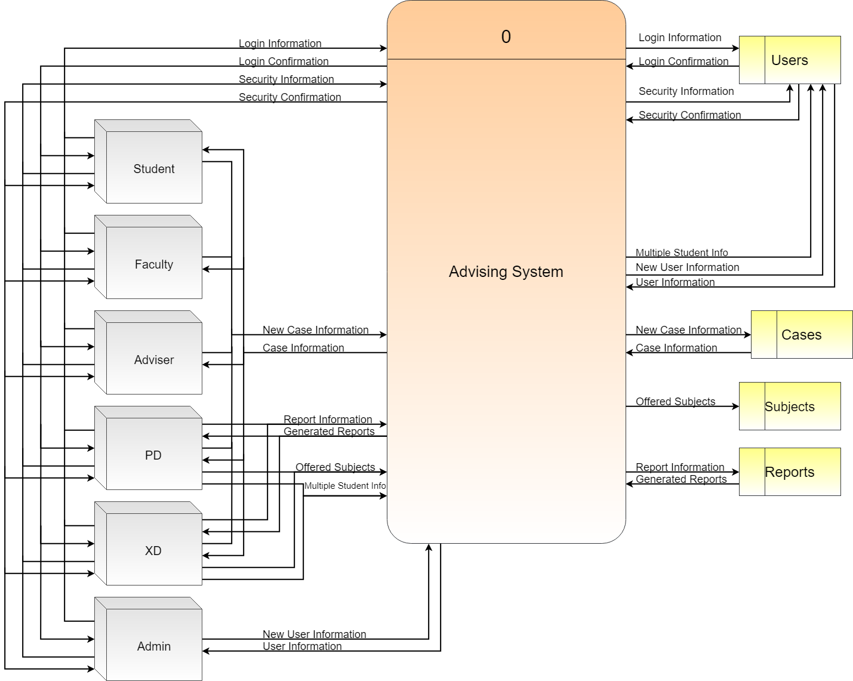

**Figure 3.5 Context Diagram**

**3.3.2. Process Details**

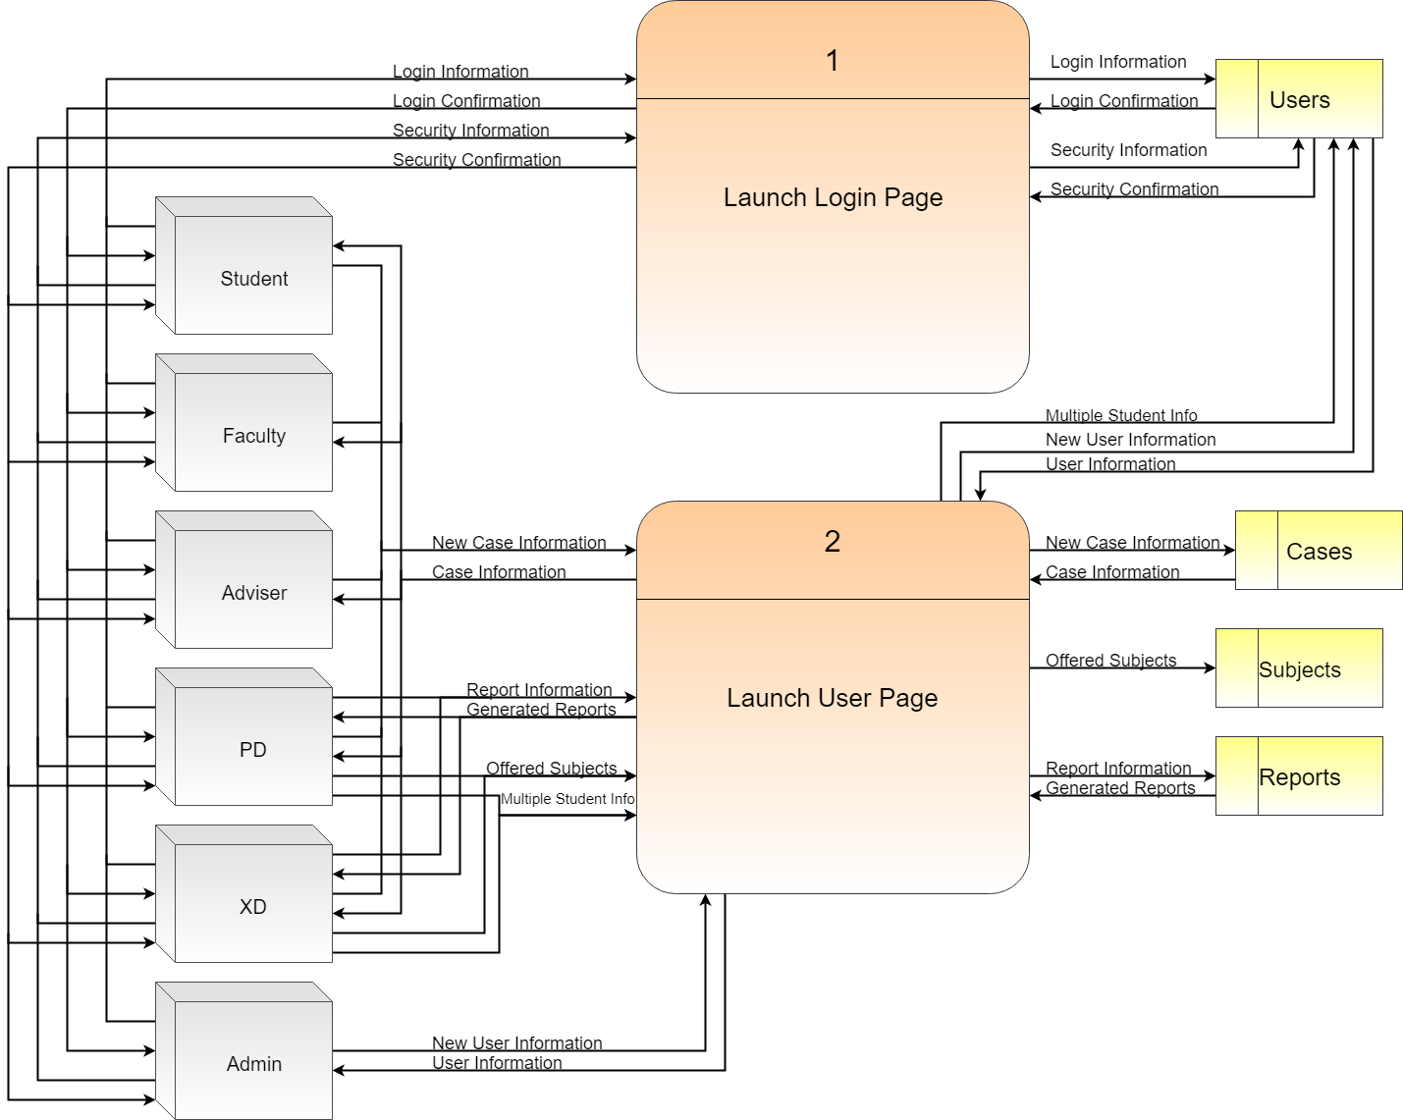

**Figure 3.6 Lvl0 Data Flow Diagram**

The Lvl0 is composed of 2 processes which is the login page and the user pages. The login page is where the users verify and confirm their login information and security details. The user pages are for the user’s corresponding pages with their respective modules.

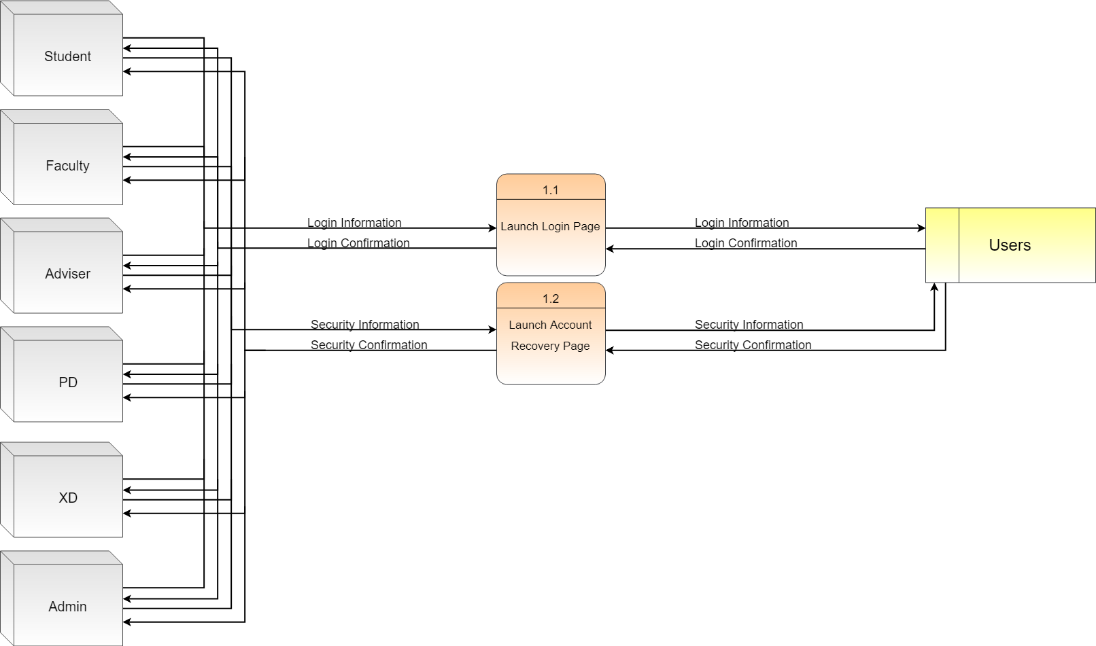

**Figure 3.7 Lvl1: Launch Login Page**

The exploded view of the Lvl1’s login page is shown in Figure 3.7. The login module’s inputs and outputs are generalized for the sake of spacing and redundancy, but in the inputs and outputs.

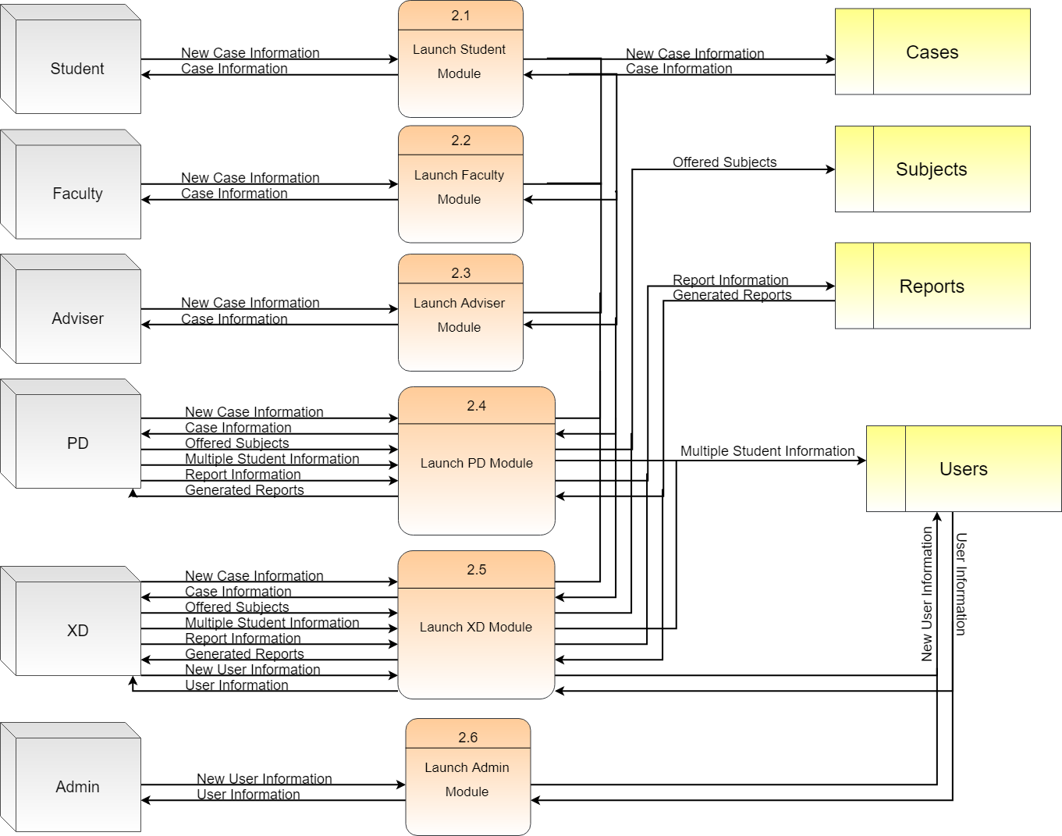

**Figure 3.8 Lvl1: Launch User Page**

The exploded view of the Lvl1’s user page is shown in figure 3.8. Each entity’s individual inputs are specified for the visualization of inputs a user or entity has.

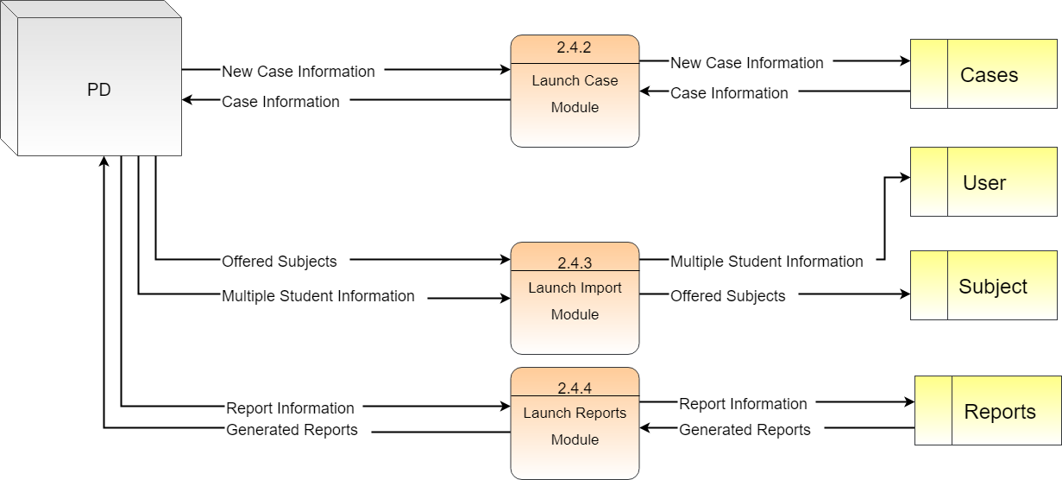

**Figure 3.9 Lvl2 DFD: Program Director (PD)**

The program director (PD) has three processes: case module, import module and reports module. The case module is similar to the student, faculty, and adviser where they input new case information and could view other case information that are accessible corresponding to their power. Import module is where the PD can import the subjects offered during the term and multiple student information as new users in the users table. A reports module is where only both the PD and XD could utilize. The reports information inputted are the parameters of the reports to be generated and the generated reports could be in a form of pdf or excel file.

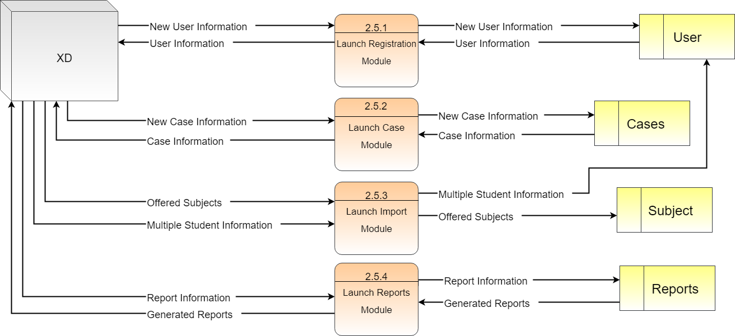

**Figure 3.10 Lvl2 DFD: Executive Director (XD)**

The executive director (XD) has one more process than the PD, which is the registration module where the XD could register new single users. This process is specifically for special case students like transfer students, and for faculty members. Another single process entity is the admin, although it has similar inputs for a process with the executive director(XD), the admin’s module has a different level of input like how the admin can edit the details of any user while the XD could only create. As seen in Figure 3.8, the student, faculty, and adviser entities uses the same module which is the case module. The case module is where they input new case information and could view other case information that are accessible corresponding to their power.

**3.4 Hierarchy**

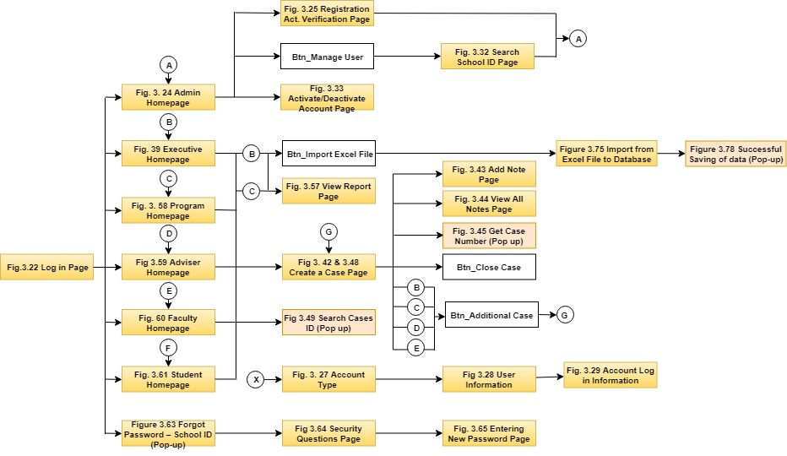

**Figure 3.11 Main Hierarchy**

Figure 3.11 shows the overall flow of the system depending on the position of the user and when the user forgot his password.

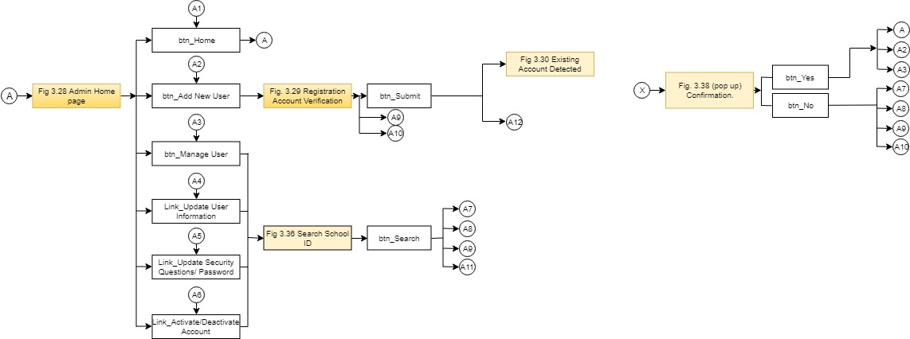

**Figure 3.12 Admin Hierarchy (A)**

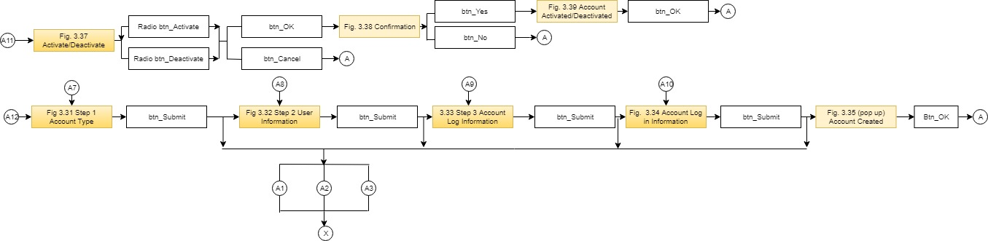

**Figure 3.13 Admin Hierarchy (B)**

Figures 3.12 and 3.13 show the hierarchal processes of the admin user. It contains the elements utilized from the admin menu page as well as the registration page.

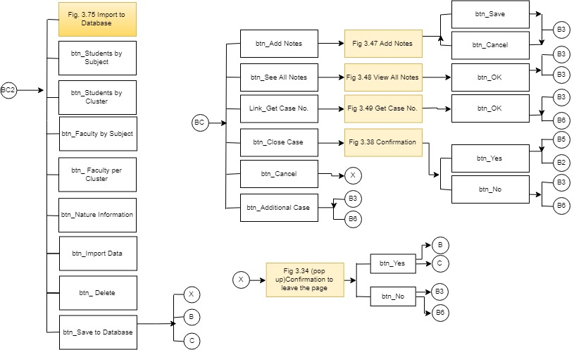

**Figure 3.14 Adviser Hierarchy (A)**

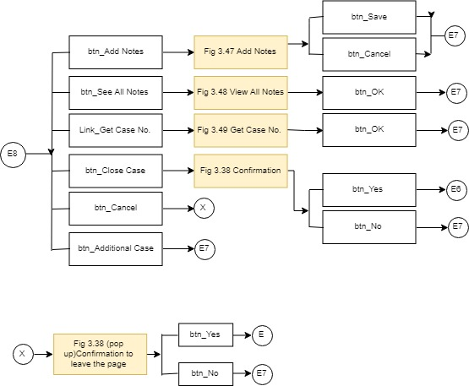

**Figure 3.15 Adviser Hierarchy (B)**

Figures 3.14 & 3.15 show the hierarchal processes of the adviser user. It contains the elements utilized from the adviser menu page as well as the case page.

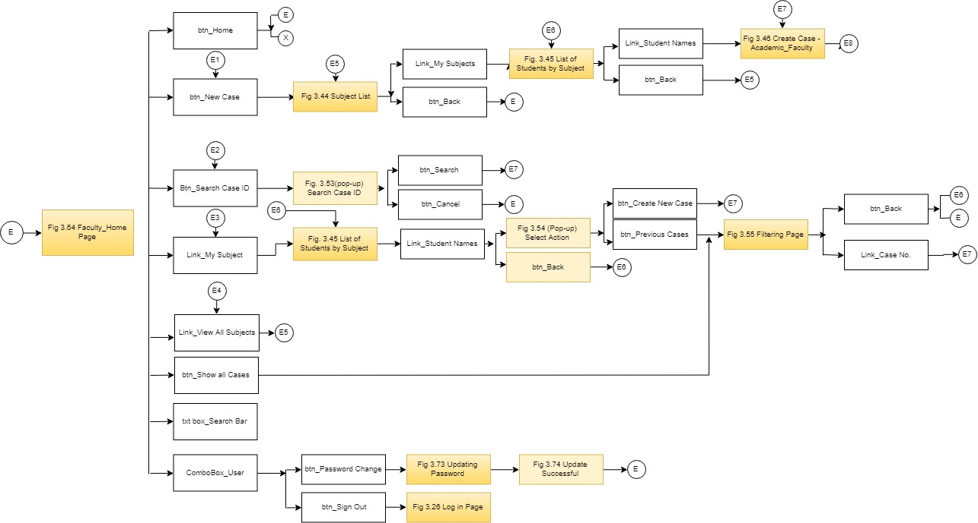

**Figure 3.16 Faculty Hierarchy (A)**



**Figure 3.17 Faculty Hierarchy (B)**

Figures 3.16 and 3.17 show the hierarchal processes of the faculty user. It contains the elements utilized from the faculty menu page as well as the case page.

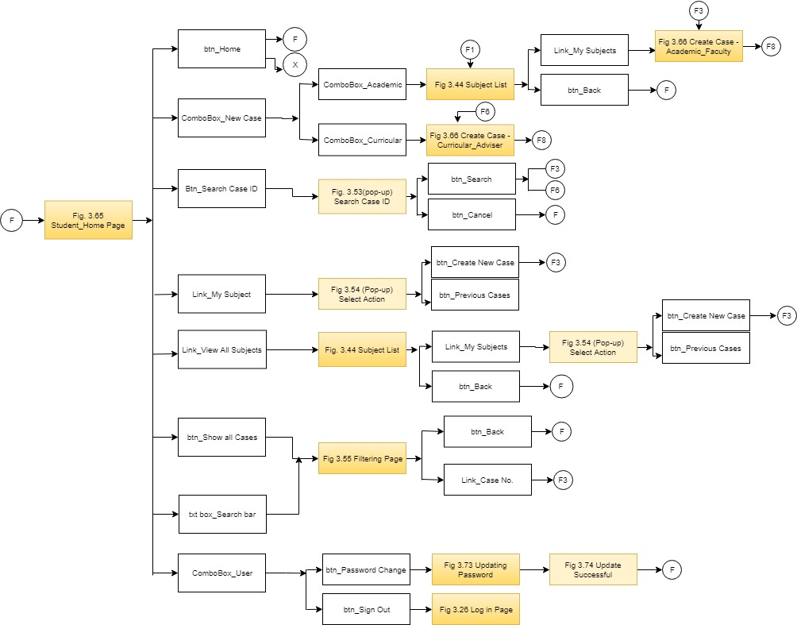

**Figure 3.18 Student Hierarchy (A)**

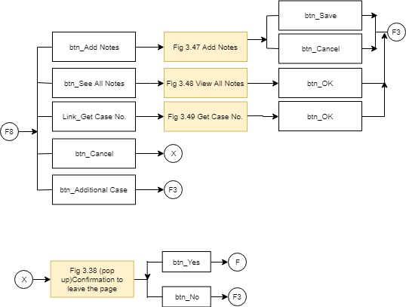

**Figure 3.19 Student Hierarchy (B)**

Figures 3.18 and 3.19 show the hierarchal processes of the student user. It contains the elements utilized from the student menu page as well as the case page.

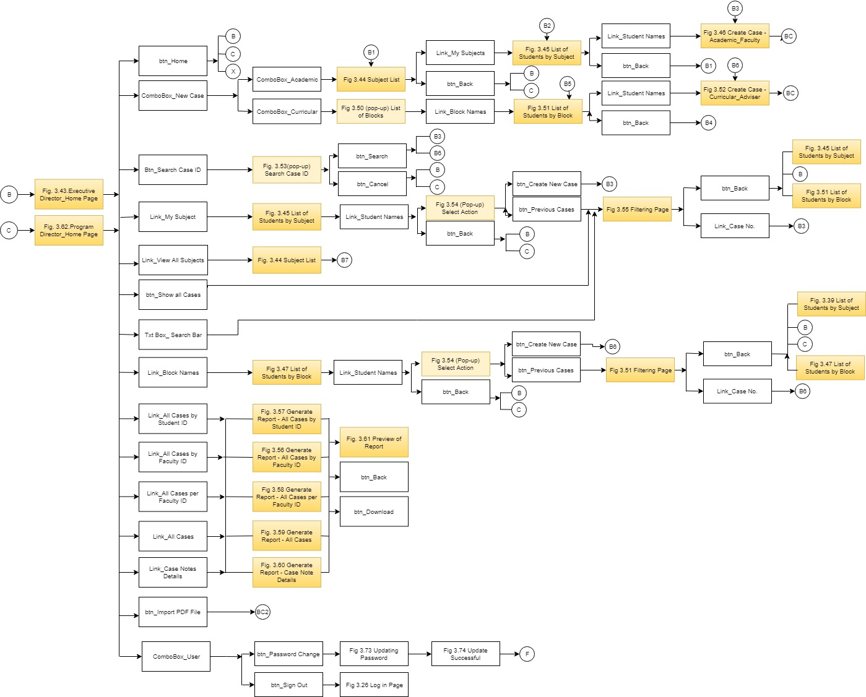

**Figure 3.20 Executive Director and Program Director Hierarchy (A)**

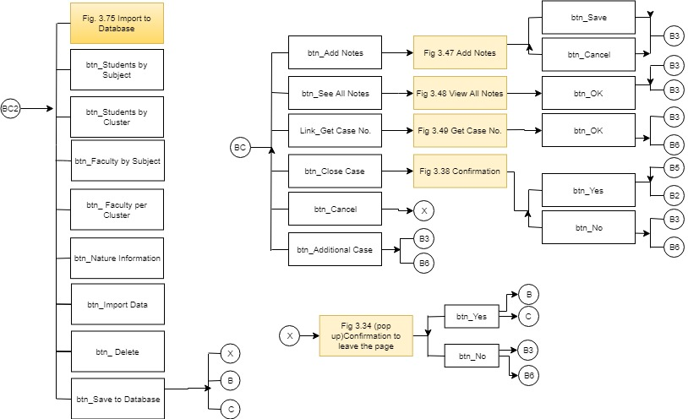

**Figure 3.21 Executive Director and Program Director Hierarchy (B)**

The figure 3.20 and 3.21 show the hierarchal processes of the XD or PD user. It contains the elements utilized from the XD or PD menu page as well as the case page, reports page, and import page.

**3.5 User Interface**

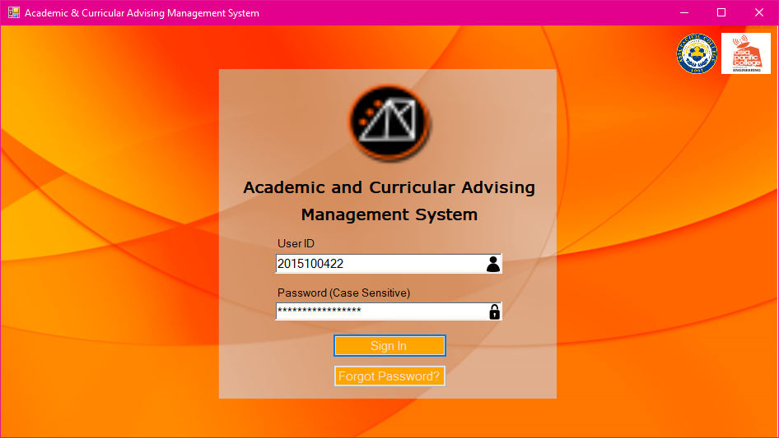

**Figure 3.22 Log in Page**

Figure 3.22 is the user login page. The page allows all users to enter login information such as User ID and Password. The user ID is automatically the school ID number of the user. There is also a hyper link available in case the user has forgot the password.

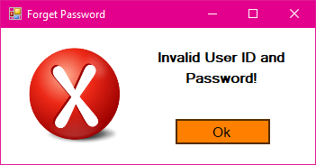

**Figure 3.23 Invalid Log in Information (Pop up)**

If the input in User ID and password is incorrect, this pop-up message will display.

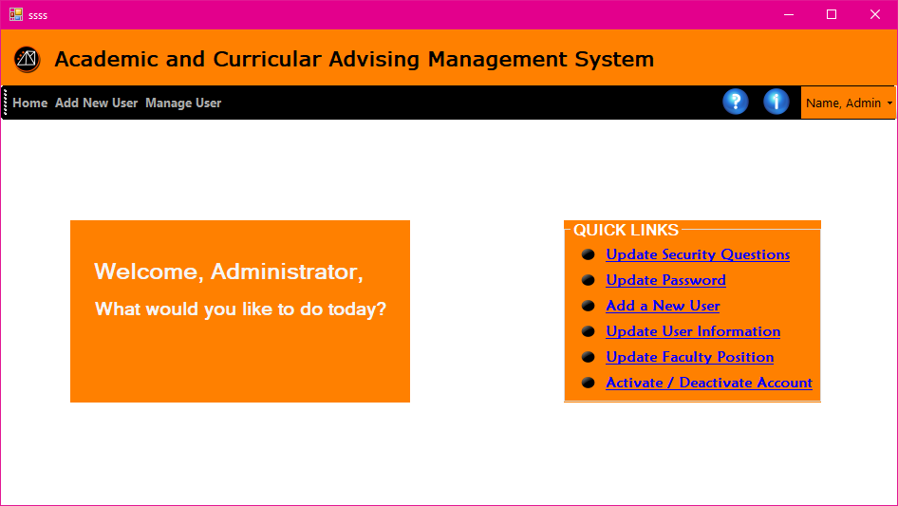

**Figure 3.24 Admin Homepage**

Figure 3.24 is the admin homepage. This is the portal where admin can access the registration module and user information module. It also has quick links that directs to the most visited page.

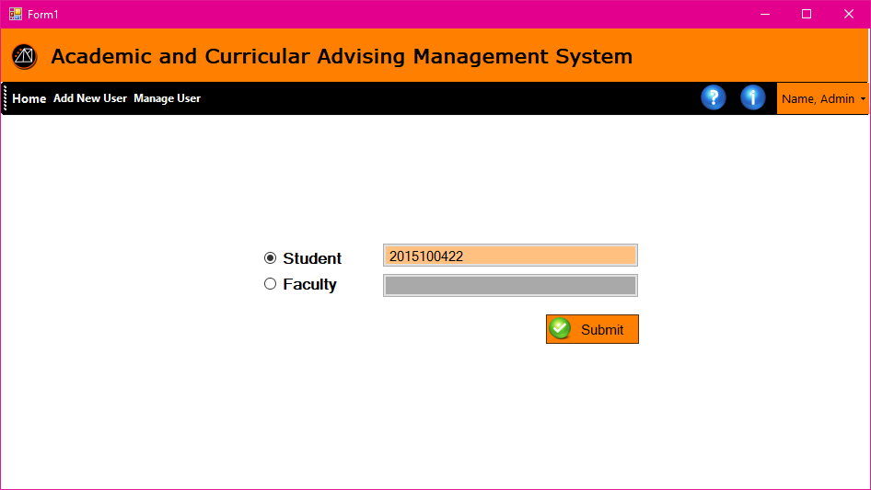

**Figure 3.25 Registration Account Verification**

Registration Account Verification page allows the admin to enter the desired school ID for registration. It has a radio button to identify either the user is a student or a faculty. The system is programmed to search for existing account before proceeding to the registration to avoid multiple account under same ID number.

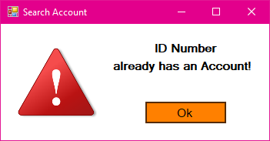

**Figure 3.26 Existing Account Detected (Pop up)**

If the account registering is already registered, this pop-up message will display.

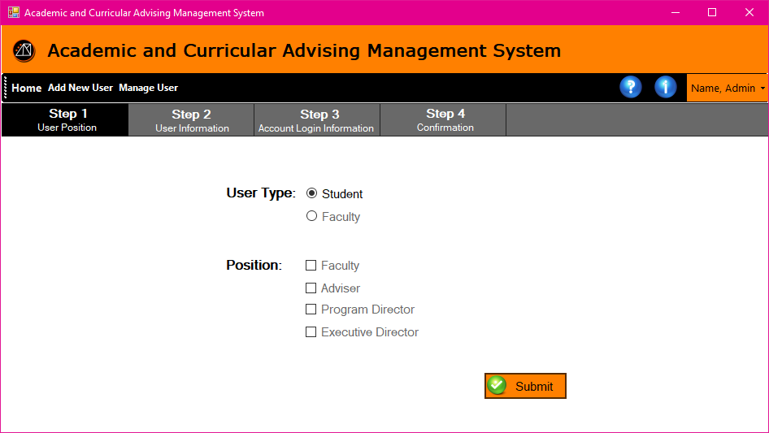

**Figure 3.27 Step 1 Account Type**

Step 1 of registration allows the administrator to select the user type. If student is selected the position will not be available for selection.

In figure 3.28, the Registration page step 2 will allow the user to enter the user information. The ID and the School is not editable from this part of the registration. The rest are user defined information which are required to fill out before proceeding to the next steps

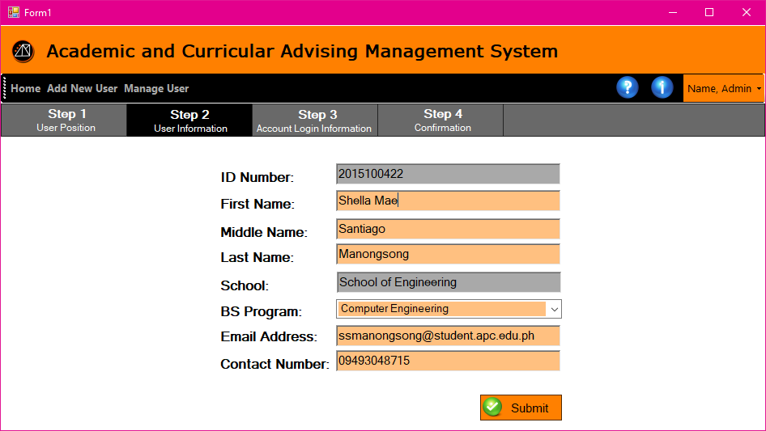

**Figure 3.28 Step 2 User Information**

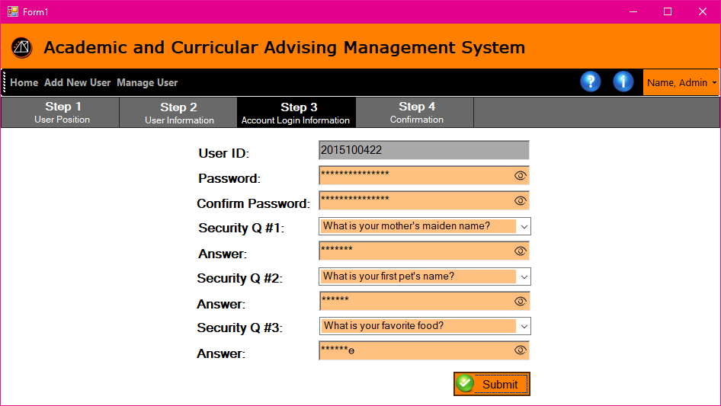

**Figure 3.29 Step 3 Account Log in Information**

Registration page step 3 – Account login information allows the user to setup his password and reconfirm it. There is also an area to setup for 3 security question and password. This information will be used in resetting password in case forgotten.

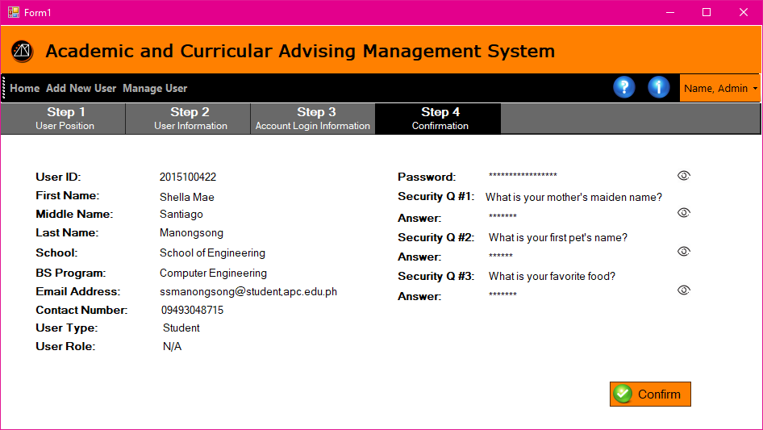

**Figure 3.30 Step 4 Account Log in Information**

Registration Page Step 4 – Account Login Information page allows the user to review all the user's information before completing the registration.

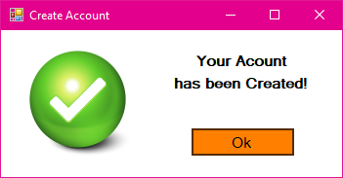

**Figure 3.31 Account Created (Pop up)**

When the user is finished registering, this pop-up message will display indicating the account is created successfully.

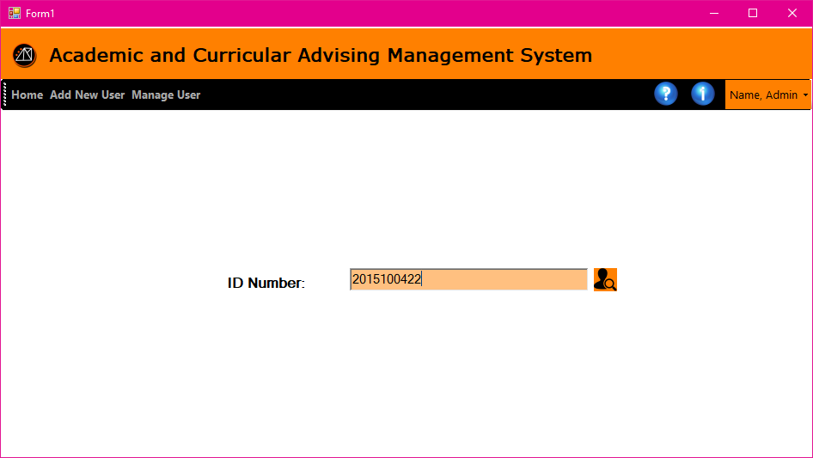

**Figure 3.32 Search School ID**

The Search School ID page allows the admin user to enter a user ID to search for a specific student.

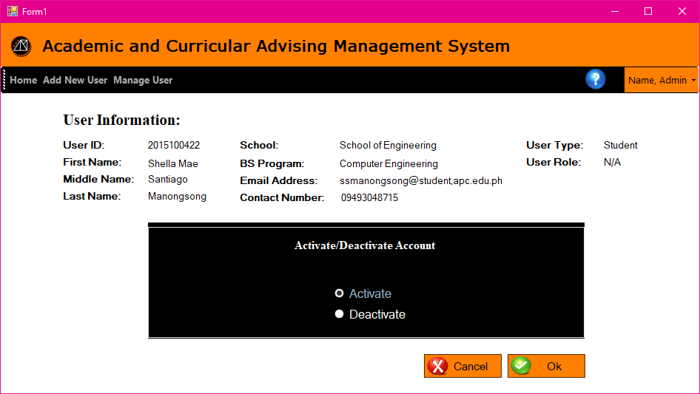

**Figure 3.33 Activate/Deactivate Account**

The Activate/Deactivate account Page allows the administrator to change the account status.

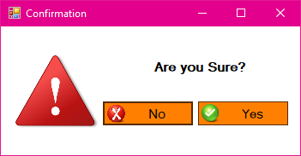

**Figure 3.34 Confirmation (Pop up)**

This page is to confirm if the user is certain before proceeding on the next step.

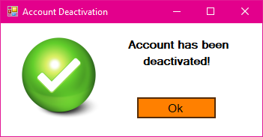

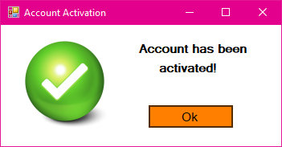

**Figure 3.35 Account activated/deactivated Confirmation (Pop up)**

This confirmation screen is to notify the admin that the request in changing the account status has successfully been processed.

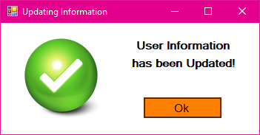

**Figure 3.36 User Information Updated (Pop up)**

This popup will notify the admin that the user information edited has been updated.

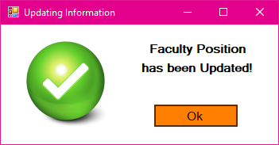

**Figure 3.37 Faculty Position Updated (Pop up)**

After editing a faculty user’s position or account type with its privileges, this popup will notify the user that the position has been updated.

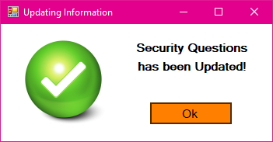

**Figure 3.38 Security Questions Updated (Pop up)**

After editing the security questions this pop-up message will display indicating the change is successful.

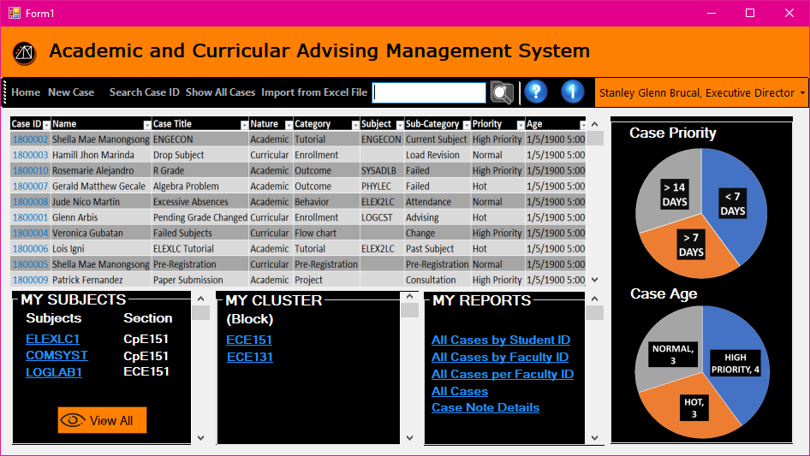

**Figure 3.39 Executive Director Homepage**

The form in figure 3.39 displays the home page of the Executive Director. This is where the summarized table of all cases is shown, and the pie chart of case priorities and its age. There is also a list of the subjects that the Executive Director is handling. There is also a cluster that has a list of all engineering students. And the reports have four types. And there is a toolbar for returning to home page, creating new case, search case ID, and showing all the cases created.

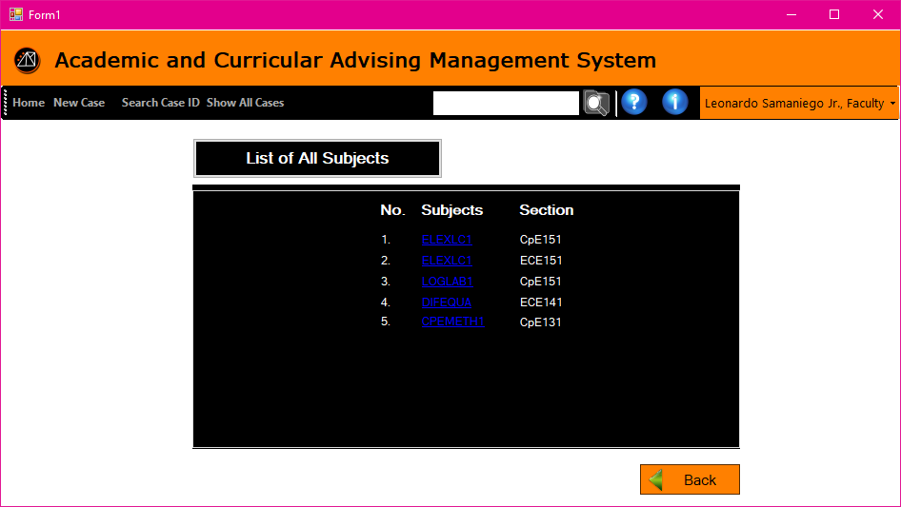

**Figure 3.40 Subject List**

The screen allows the user to view the list of subjects that he handles before proceeding to the next page which is the list of students enrolled in the subject.

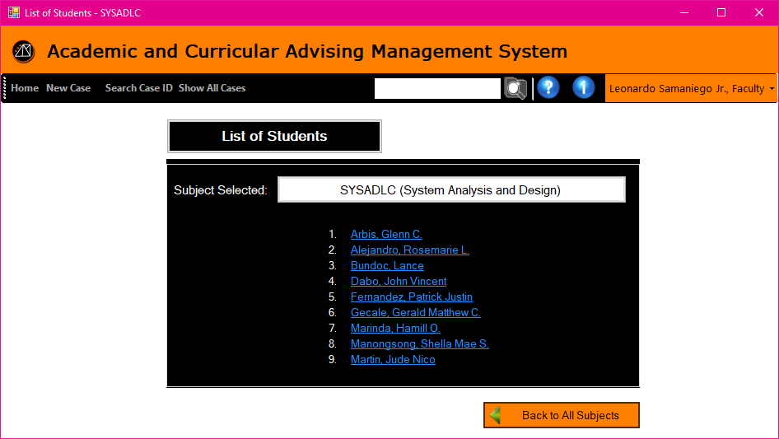

**Figure 3.41 List of Students by Subject**

This page allows the user to view the list of students who are currently enrolled in the subject.

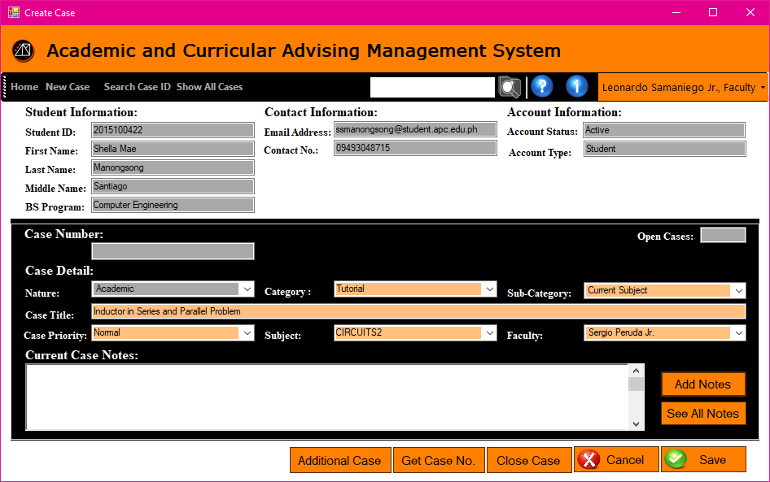

**Figure 3.42 Case Page –Academic Faculty**

* This is where the user will create a new case. The text box that are tinted with grey color cannot be edited, and automatically generated by the searched student’s information. The Open Cases on the right corner of Case Detail displays the total cases that the student has.
* The Case Detail must be all filled before it allows to click done.
* The Nature indicates if the case is Academic or Curriculum.
* The Category is if it is about a subject tutorial, academic outcome, behavior concern, project, pre-registration, enrollment or flow chart.
* The Sub-Category indicates if it is a current subject or past subject, Passed or Failed subject, attendance, grade consultation, deliverables, project output, subject advising, load revision, flowchart advising, or flow chart changing.
* The Case Title is simply the title of the new case.
* Case Priority indicates if the case is in High Priority, Normal or Hot. Hot means the case created for the student is at risk. While the other priority depends on the faculty’s note.
* Subject is the list of subjects that the faculty is handling with the specific student.
* Faculty is the name of other faculty member that you will message for a tutorial or consultation, etc.
* Current Case Notes displays all the notes sent by the student and the faculty in a small note box.
* Add Note is when the faculty wants to send the student another note, the note will just add up to the notes sent.
* See All Notes will view all the notes on a larger window.
* Get Case Number is for generating a case number whenever the user is done filling up the form.
* Close Case is a command button when the case opened is already done.
* Done is for creating the case.
* Clear is for removing all the data inputted in Case Details.
* Back is for returning to the List of Students page.

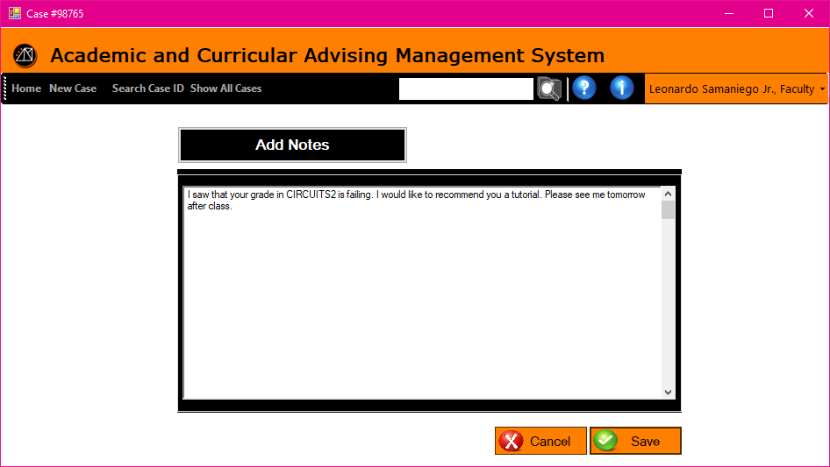

**Figure 3.43 Add Notes**

The figure 3.43 window lets the user construct a note and add to the history of their conversation. Save button is when the user is done typing and ready to add his/her note.  It also has a vertical scroll bar in case the user typed a long note.

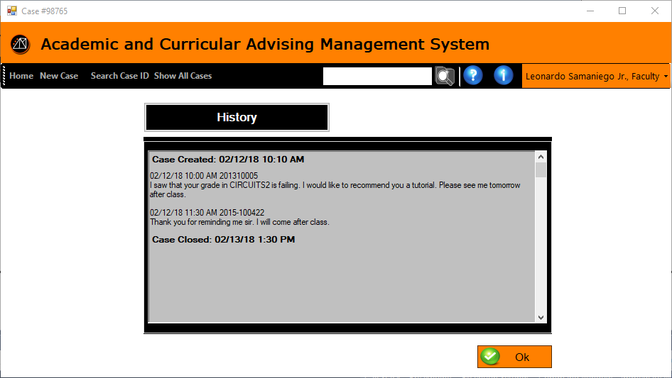

**Figure 3.44 View All Notes**

This page displays the history of the notes sent by the two users.

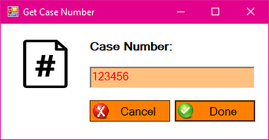

**Figure 3.45 Get Case Number (Pop up)**

This pop-up window will display whenever Get Case No. button is clicked to generate a unique case ID number when creating a new case. 

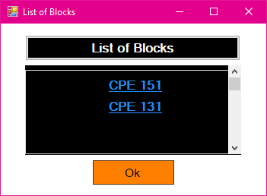

**Figure 3.46 List of Blocks (Pop up)**

This page allows the user to view all block he/she handles.

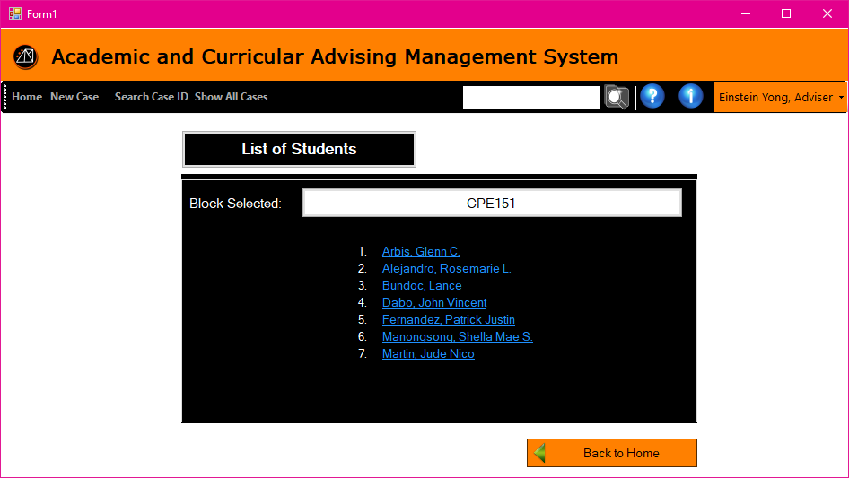

**Figure 3.47 List of Students by Block**

This window displays the list of students in a block that is hyperlinked to decide whether to create a new case to the student or view all his/her cases.

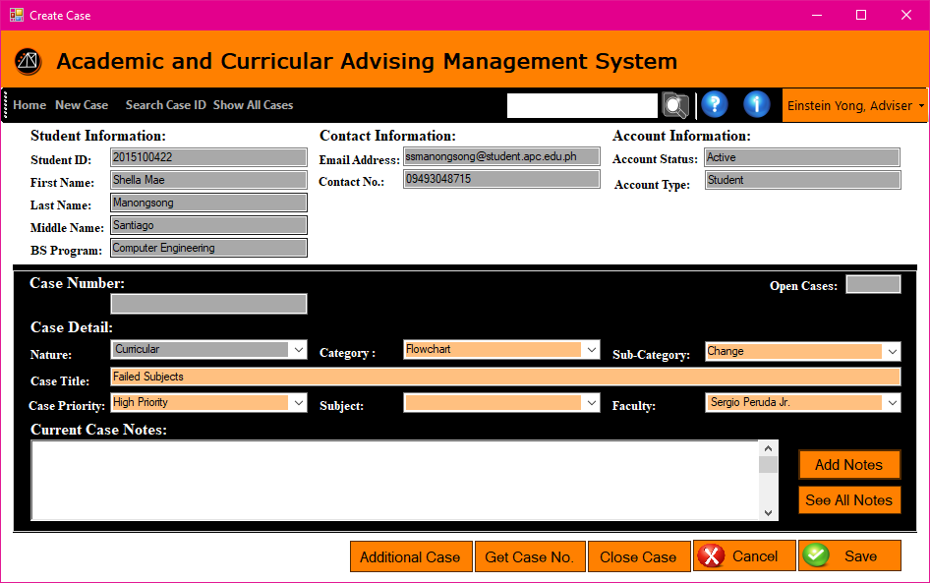

**Figure 3.48 Case Page – Curricular Adviser**

The buttons and displays are the same with figure 3.37. This page allows the adviser to create a case intended only in the nature of curricular.

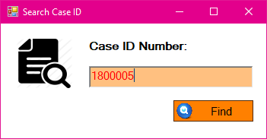

**Figure 3.49 Search Case ID (Pop up)**

The page allows the user to enter the case ID prior to pulling up the case.

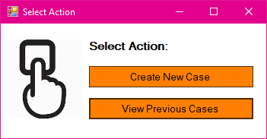

**Figure 3.50 Select Action (Pop up)**

This page allows the user to select he would like to create a new case or view previous cases.

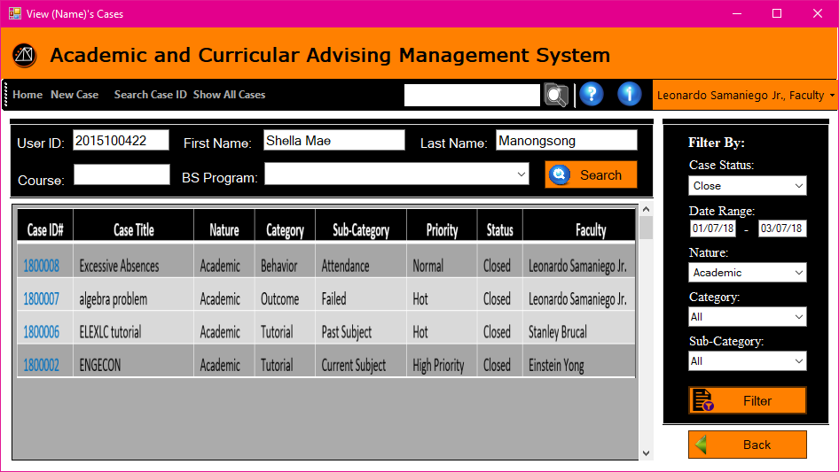

**Figure 3.51 Filtering Page**

This page allows any faculty level user to search for case by entering either the user ID, first name, last name, course, or BS Program. It will produce a queue of results that are related information provided. It also has a section to further filter the search result.

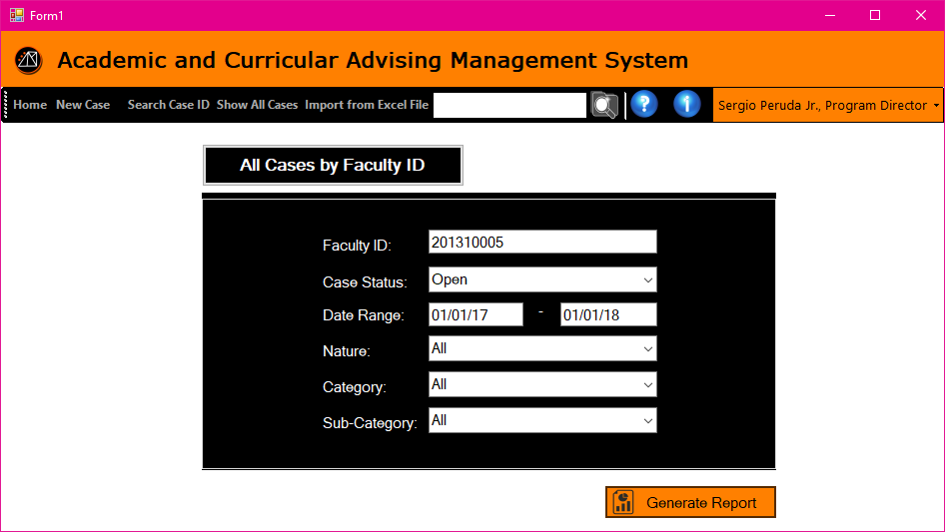

**Figure 3.52 Generate Report – All Cases by Faculty ID**

The page allows the PD/XD user to enter the information that will be needed in generating a report. The form needs to be filled up if the user is looking for case related to one faculty only.

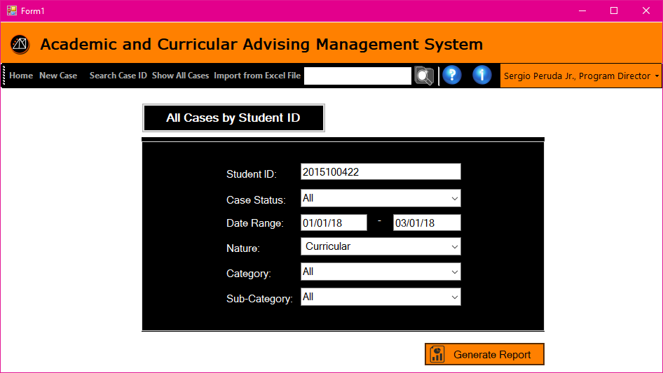

**Figure 3.53 Generate Report – All Cases by Student ID**

The page allows the PD/XD user to enter the information that will be needed in generating a report. The form needs to be filled up if the user is looking for case related to one student only.

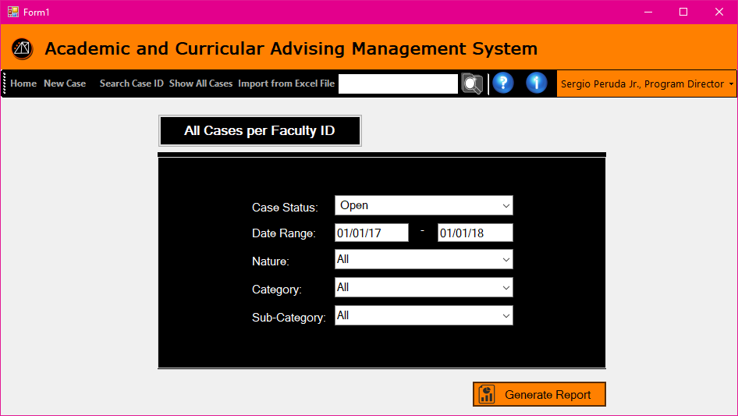

**Figure 3.54 Generate Report – All Cases per Faculty ID**

The page allows the PD/XD user to enter the information that will be needed in generating a report. The form needs to be filled up is the user is looking for all faculty related cases within a date range.

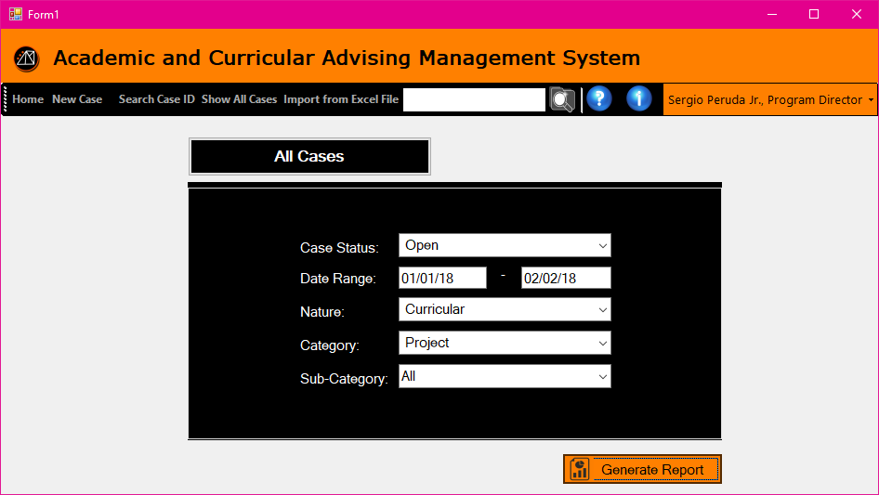

**Figure 3.55 Generate Report – All Cases**

The page allows the PD/XD user to enter the information that will be needed in generating a report. This form needs to be filled up if the user would like to pull up all case within a data range for a specific case status.

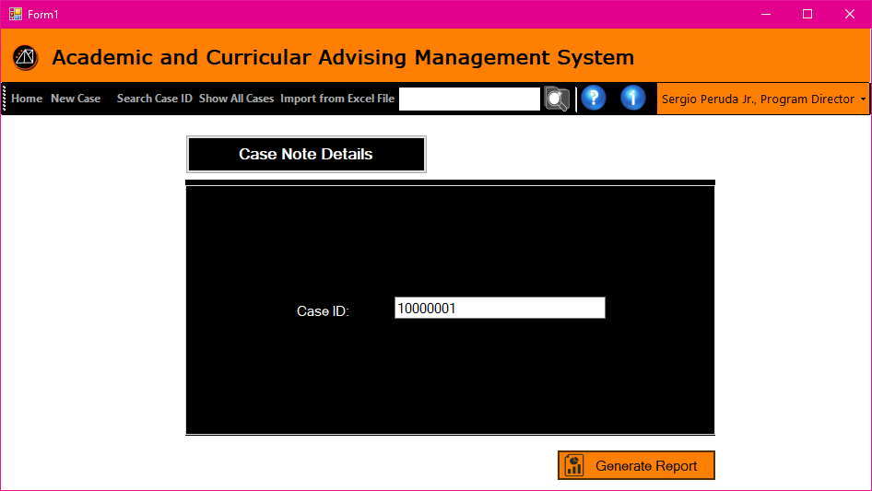

**Figure 3.56 Generate Report – Case Note Details**

This allows the PD/XD user to search for a specific case to create a report with.

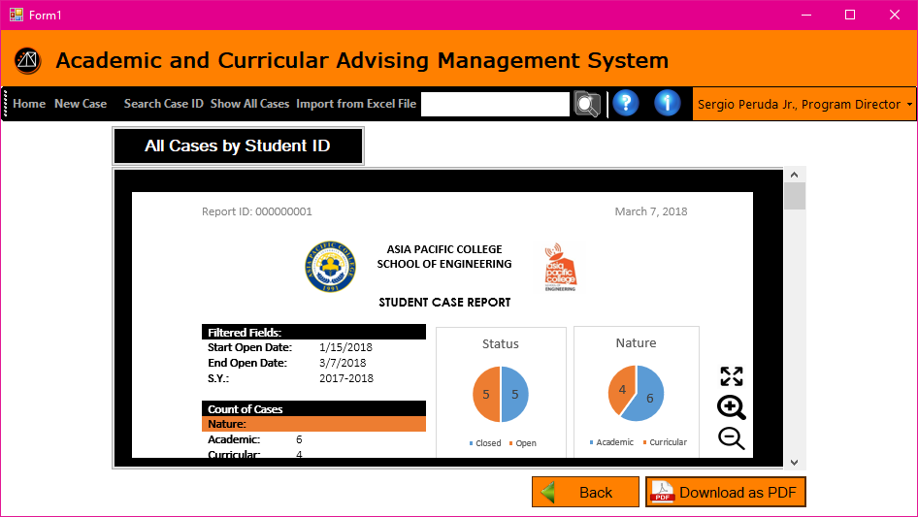

**Figure 3.57 View Report**

The page shows the preview of the report that the user created.

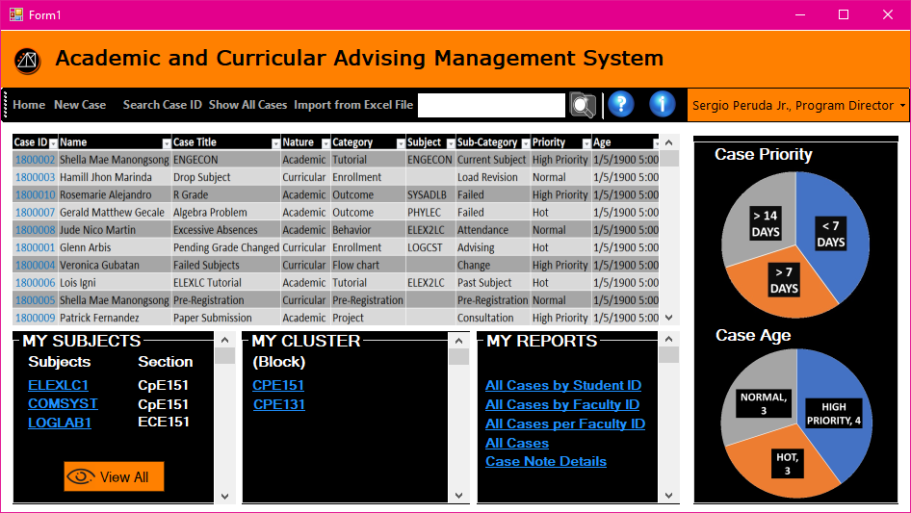

**Figure 3.58 Program Director Homepage**

Fig 3.56 is a form similar to the Executive Director's privilege, which displays the home page of the Program Director. This is where the summarized table of all cases is shown, and the pie chart of case priorities and its age. There is also a list of the subjects that the Program Director is handling. There is also a cluster that has a list of all engineering students. The reports have 4 types. The user can create a new case, search case ID, and show all the cases created.

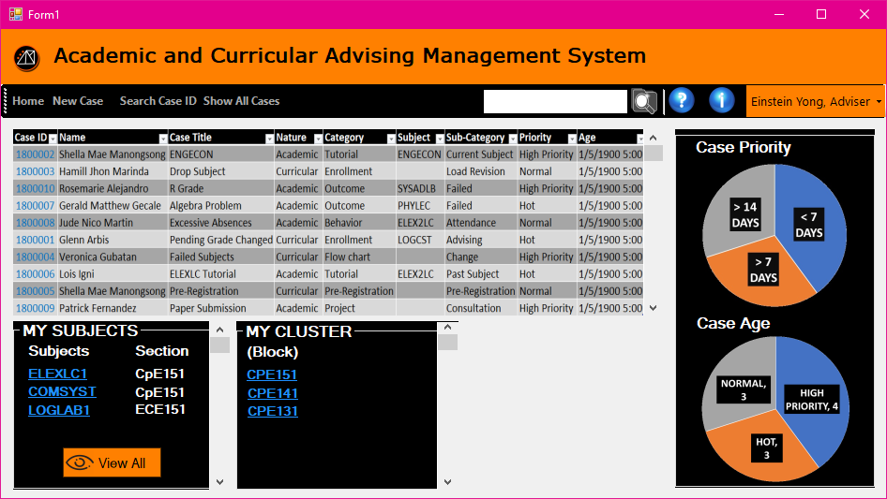

**Figure 3.59 Adviser Homepage**

The page shows the homepage for adviser. This page is similar to the faculty page. The added section is My Cluster that displays the hyperlinks of the blocks he/she handles.

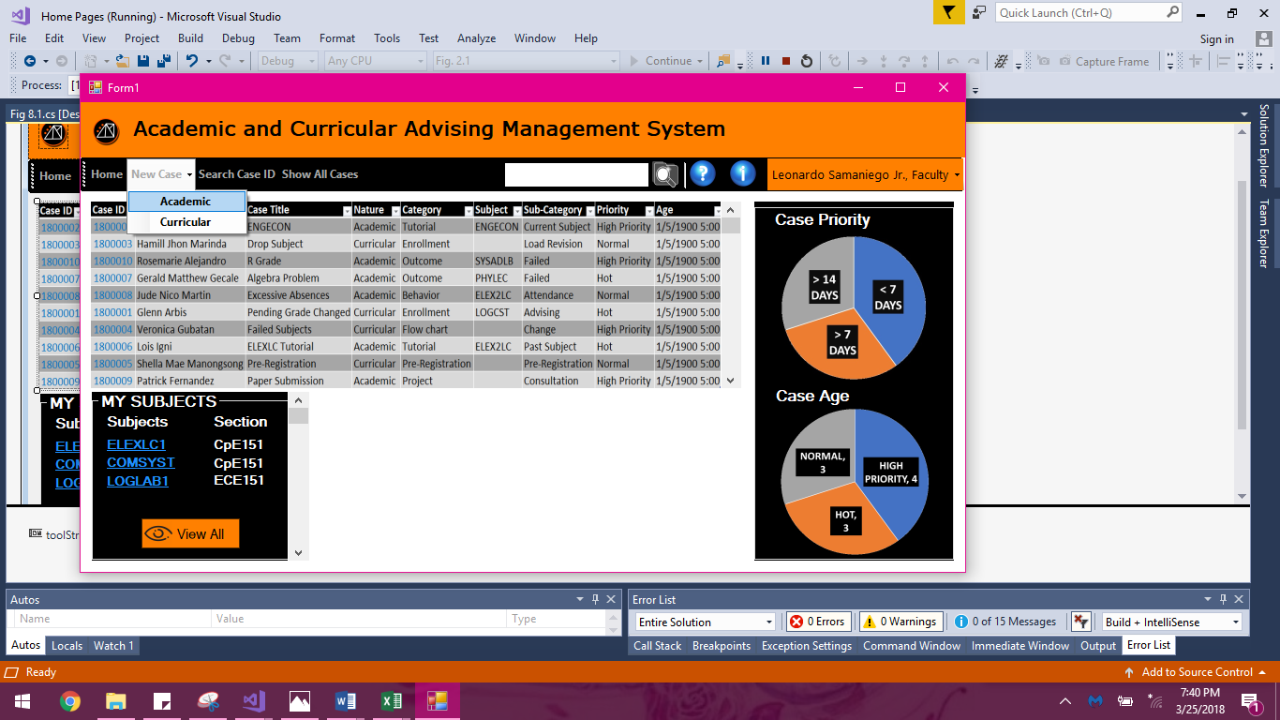

**Figure 3.60 Faculty Homepage**

This is the faculty’s homepage after logging in successfully.

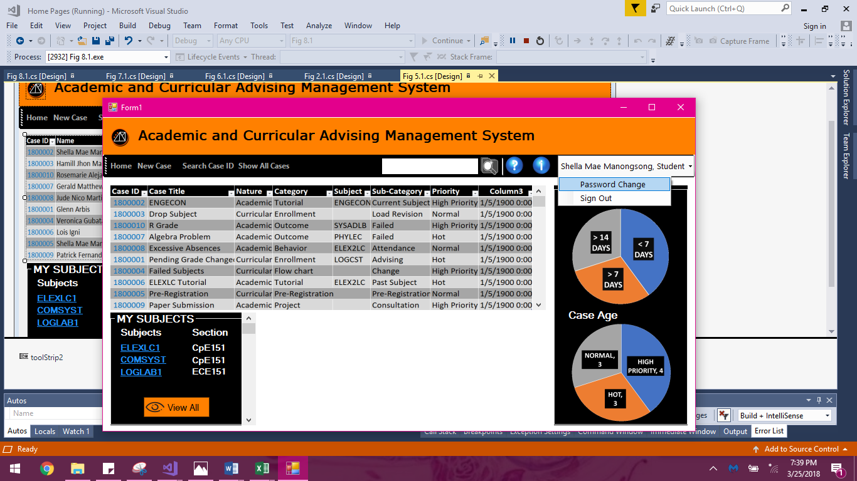

**Figure 3.61 Student Homepage**

This is the homepage ofthe student with my subject box and pie graph to see the summary of case priority and case age. He can create a case, search case ID and show all cases.

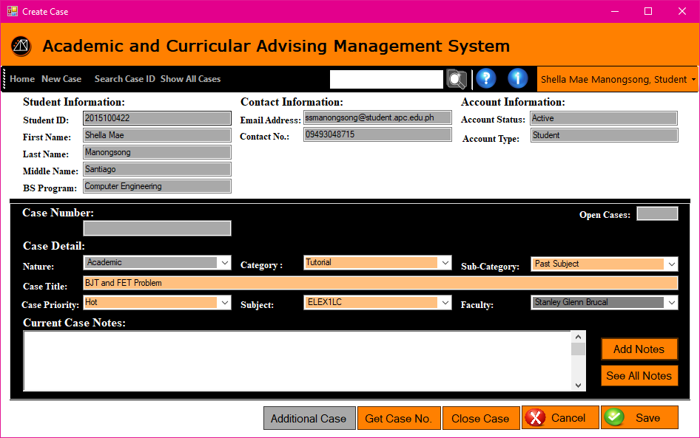

**Figure 3.62 Case Page – Academic / Curricular Student**

Fig 3.62 is the case page where in the student allows to create a case but cannot create additional case, because the faculty can only decide if it is an additional case and the case created by student is still in request until the faculty accepts it.

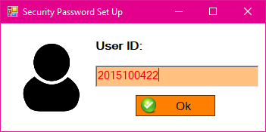

**Figure 3.63 Forgot Password – School ID (Pop-up)**

When the user clicked the Forgot Password button, this pop-up window will display. The user have to enter his/her user ID to identify which account is it.

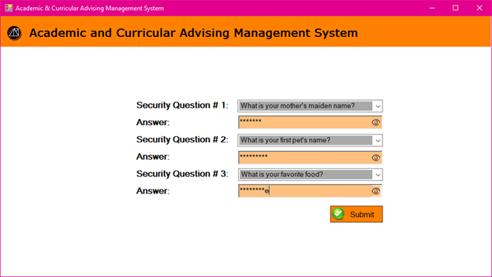

**Figure 3.64 Forgot Password – Security Question**

The user is required to answer the security questions he/she has chosen during his/her registration. Answering them all correctly will give the user the privilege in changing his/her password.  
   
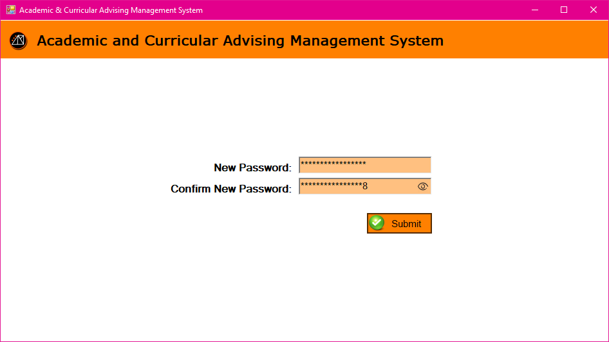

**Figure 3.65 Forgot Password – Entering the New Password**

The user can now enter his/her new desired password twice for confirmation/case sensitivity purposes.

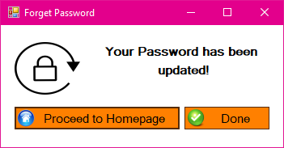

**Figure 3.66 Forgot Password – Update Successful (Pop up)**

Confirmation and a notification popup where the user will be redirected to their homepage.

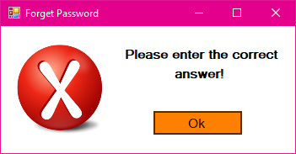

**Figure 3.67 Forgot Password – Invalid Answer(s) Prompt (Pop up)**

A popup notifying the user that his/her answers in the security questions are incorrect.

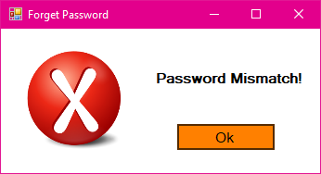

**Figure 3.68 Forgot Password – New Password Input Mismatch (Pop up)**

A popup notifying the user that his/her newly entered passwords are mismatched. 

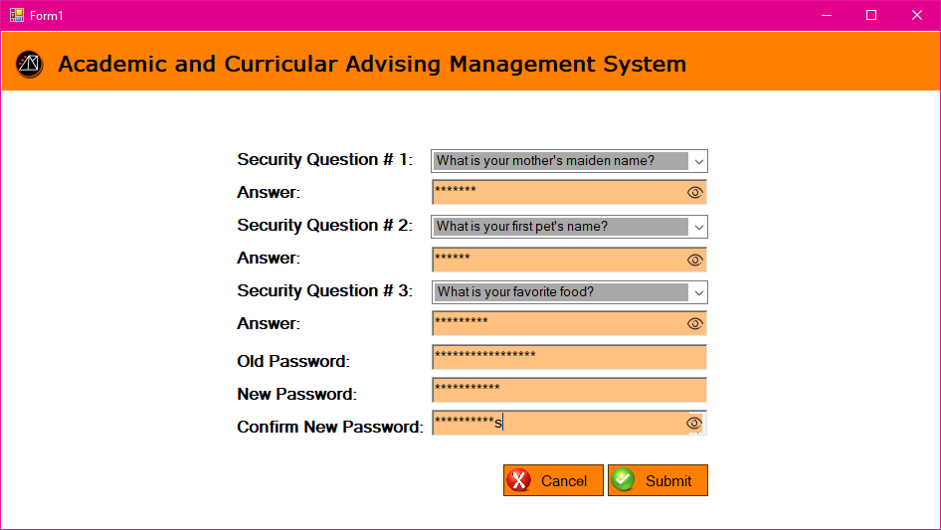

**Figure 3.69 Updating Password**

When the user wants to change his/her password, the user needs to comply this form for security purposes.

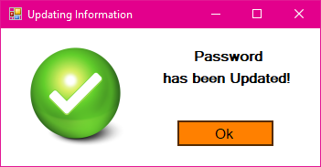

**Figure 3.70 Updating Password – Update Successful (Pop up)**

When the user is done with the form this pop-up message will display indicating the user’s password is updated successfully.

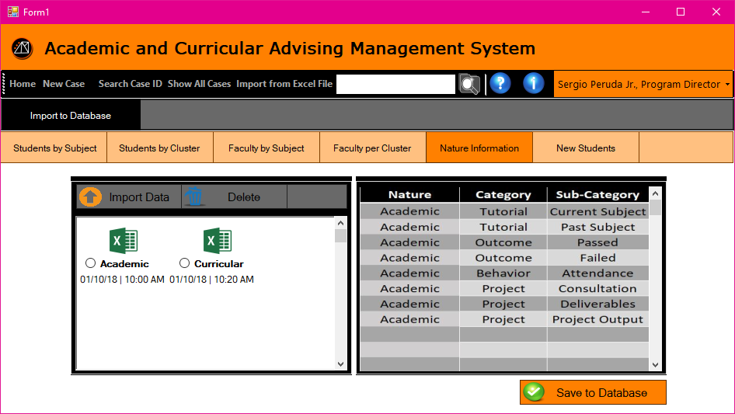

**Figure 3.71 Import from Excel File to Database**

This is the sample of user interface when the user picked a section where he/she wanted to add the information from the excel file he/she imported.

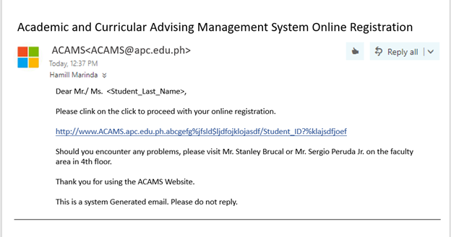

**Figure 3.72 Email**

After importing the list of students by the Executive and Program Directors, a default email will be sent to the APC email of the students listed. The students will receive an email containing a link direct to the registration of the system.

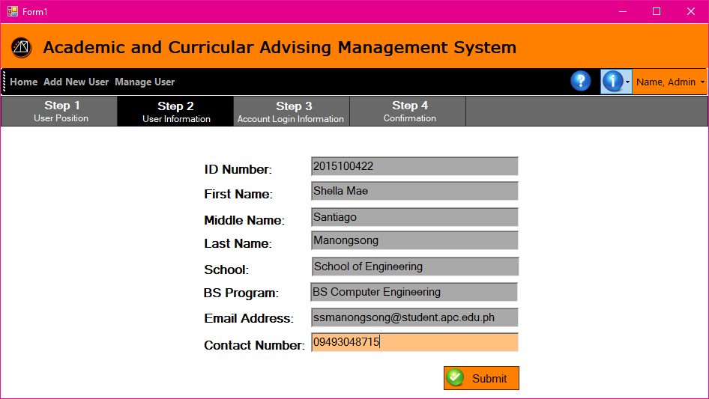

**Figure 3.73 Step 2 User Information not edited**

After clicking the link from the email sent by the system, this page will display. The text boxes with grey highlights are not editable, the information stored in it is bases on the data imported by the executive/program director, and the student will only fill the data for their contact number.

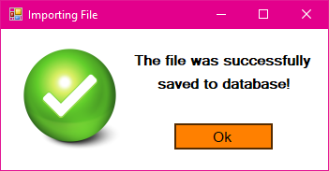

**Figure 3.74 Successful Saving of data (Pop-up)**

After importing of excel file containing data that will be added to the database, this pop-up window will display indicating that the data uploaded is saved successfully.

**3.6 Reports**

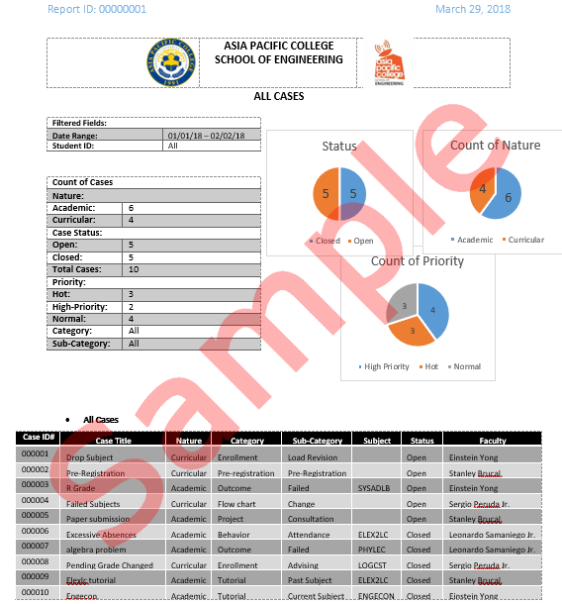

**Figure 3.75 All Cases A**

The figures 3.75 and 3.76 are examples of a multiple case generated report. It consists of the list of cases selected by the XD and PD from their inputted date range and categories.

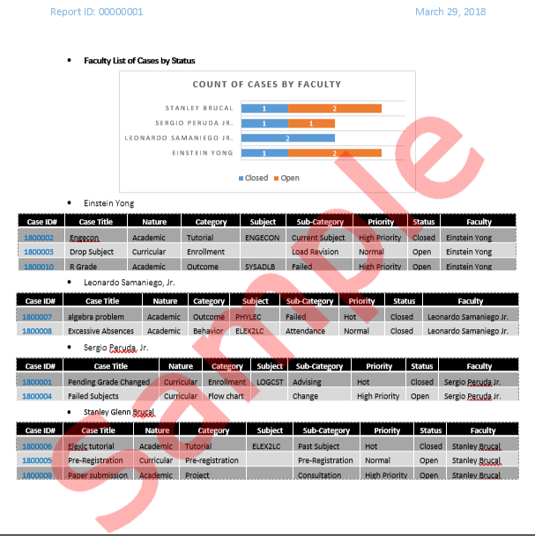

**Figure 3.76 All Cases B**

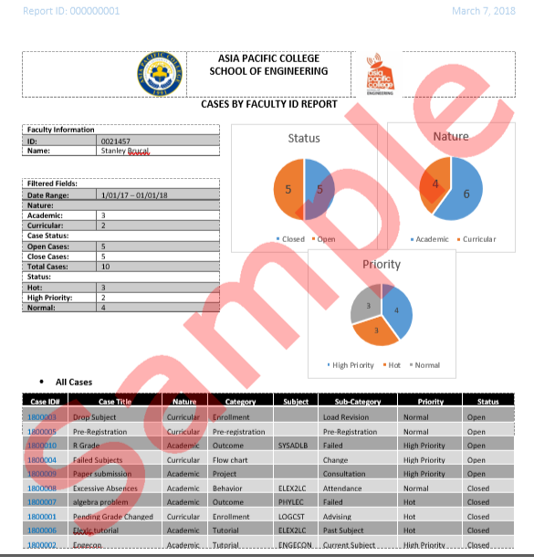

**Figure 3.77 Cases by Faculty ID Report**

In figure 3.77, the report generated a report from the XD, or PD user. A report that shows all the reports open or closed involving themselves**.**

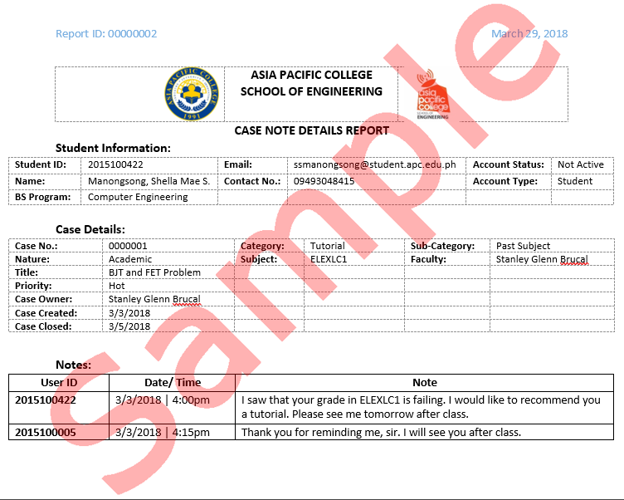

**Figure 3.78 Case Note Details Report (Closed)**

The figure 3.78 is a generated report of a single student selected by either the XD, or PD, showing all the case details along with the interaction via case notes between the case owner and the selected student.

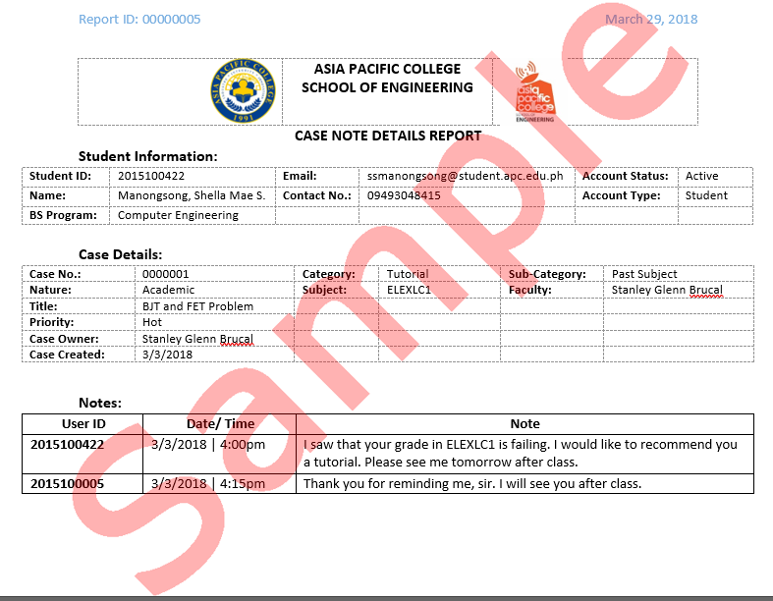

**Figure 3.79 Case Note Details Report (Open)**

The generated report in figure 3.79 is a report of an individual student selected by either the XD, or PD, showing all the case details along with the interaction via case notes between the case owner and the selected student.

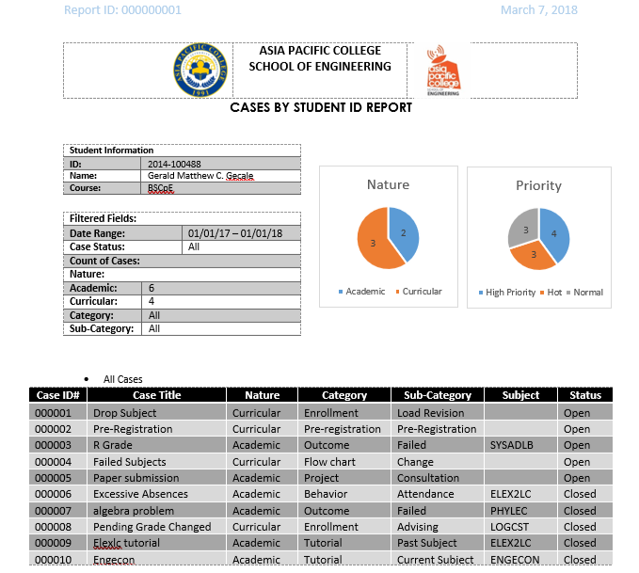

**Figure 3.80 Cases by Student ID Report**

The figure 3.84 is a generated report that shows both open and closed cases of a selected student with the case details. The report shows only the cases from the selected date range.

**3.7 Methods, Tools, and Techniques**

**Table 3.2. Methods**

|  |  |  |
| --- | --- | --- |
| **Methods** | **Tools** | **Techniques** |
| Automated | * Computer * Internet Connection * Database Server | User Database Management System |
| Automated | * Computer * Internet Connection * Case Database Server | Case Database Management System |
| Automated | * MySQL Workbench * Draw.io | Entity Relationship Diagram: Crowfoot Notation |
| Automated | * Draw.io | Business Process Model: Data Flow Diagram (LvL0, LvL1, Lvl2) |
| Automated | * Microsoft Excel | Data Dictionary: Normalization |

**3.7.1. Tools**

* MySQL Workbench – the group used MySQL Workbench to create the system's Entity Relationship Diagram. This software helped us in properly placing the mandatory forms of the entities with the crowfoot method.

* Draw.io - this online drawing tool was used for creating the extended Entity Relationship Diagram, and the Data Dictionary, from the Context Diagram (LvL0), LvL1, and Lvl2.

* Microsoft Visual Studio (2013-2016) - this software was our vital tool in creating the group's user interfaces.

* Microsoft OneNote – this online file collection and collaboration tool was used for the organization and arrangement of our documentation, as well as our images or figures for the documentation.

**3.6.2. Techniques**

The proponent conducted interviews with the client in order to fully understand the processes and functions needed in the system. People who are involved in the system was distinguished from the interviews as well. For the refinement of the processes and specifications of the system, follow-up consultation and interviews were actively conducted in order for the additional changes that were needed are clarified and verified.

* Crowfoot Notation – a database management method used in the Entity Relationship Diagram to assign the relationship of entities with other entities. The lines used to connect the entities have certain figures at the ends of the lines depending on the nature of the relationship. Figures that looks like a crow's foot getting the name Crowfoot Notation.

* Normalization of Tables – the processes of reconstructing a database system's tables to reduce data redundancy and makes the tables more organized and accessible in an orderly fashion.

**3.8 Infrastructure**

From the figure 3.62, the minimum requirements of the Academic & Curricular Advising Management System that being the system to be an intranet, a server, typically a basic workstation server for schools with sufficient internet speeds for optimal data transfer. Yes, the system is an intranet web-based system, but it is still necessary to have proper internet connection inside the network for maximum throughput of the networks file transfer speed. 

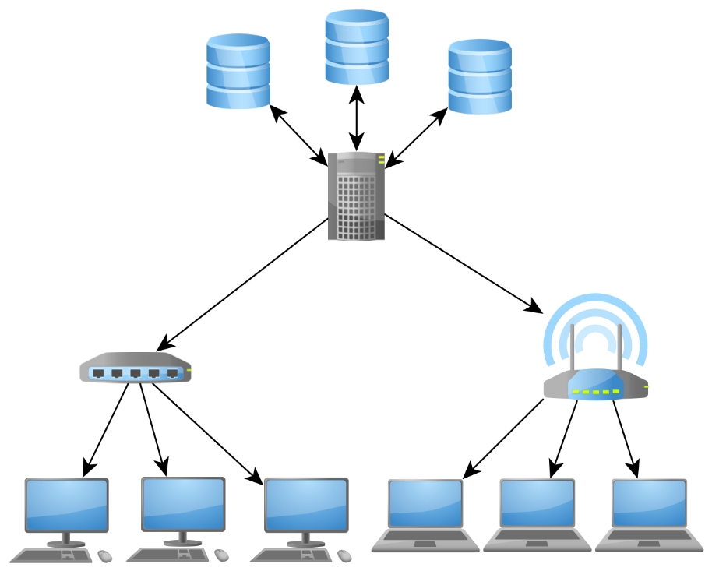

**Figure 3.81 Infrastructure**

**Internet and Network Speed Minimum System Requirements (For a small population e.g. 100 Users)**

Internet:

* Upload Speed: 15 Megabits per second
* Download Speed: 15 Megabits per second

Network: 

* Cable: CAT5E with the rating of 1000 Megabits per second, Ethernet 1000Base-T.

**Server's Minimum System Specifications Required for Possible Outside Deployment**

**OS:**Linux (Oracle, Slackware, etc. Any basic server-type Linux OS would suffice)

**Processor Specifications:** Multicore/Multi-threaded CPU (4 Cores/8 Threads)

The more threads the better depending on the quantity of the population that will use the system.

**RAM:**16GB, frequency higher than the old 1600MHz. DDR3 is still good for optimal performance but if the platform of the motherboard and processor supports DDR4, DDR4 would be most optimal for the system.

**Storage:**Hard Disk Drive with the rating of 7200RPM would be the minimum, but the utilization of an SSD, although expensive, would provide the best performance for the system.

**Graphics Card:** The system being a basic file and reports system, no powerful graphics card is necessary. The Server's System Unit needs a graphics processing unit because majority of server processors don't come with integrated graphics processing unit.

Possible minimum requirements for graphics are the following:

* NVidia GTX1030 2GB GDDR5
* AMD RX550 2GB GDDR5

**Power Supply:**Depends on the power required to power the CPU + GPU + Motherboard.    
Recommended Wattage: 600W or higher, with 80% Efficiency Rating preferably with a Bronze Rating or Higher.

**User's Minimum System Specification Requirements for his/her computer**

**Processor:**Intel Pentium 4th generation or higher,

Recommended Processor: Intel i3-4th generation or higher.

**RAM:**4GB DDR3 1600MHz+ or DDR4 2133MHz+

Recommended RAM Capacity: 8GB

**GPU:** Intel HD Graphics (Integrated) / AMD Radeon Graphics (Integrated)

Recommended: Any Discrete Graphics whether the user is using a desktop computer or portable computer (Notebook/Laptops, etc.).

**OS:**Windows 7 (64-bit) or higher versions of windows

**Web Browser:**Microsoft Edge 10, Google Chrome